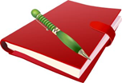
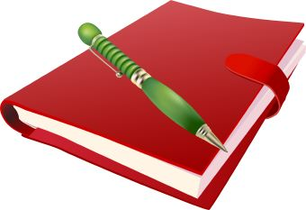
Reader’s Book Record

Reader: _____________________ Genre: ______________
Book Title: ______________________________________________________
Author: _____________________________
Date Started: ___________________ Date Finished: ____________________
AR Level: _______ AR Points: _______ AR Quiz grade: _____________
Rating: Fill in the number of stars you would give this book

Explain your rating in two paragraphs, one explaining what you liked and one explaining what you didn’t like.
______________________________________________________________________________________________________________________________________________________________________________________________________________________________________________________________________________________________________________________________________________________________________________________________________________________________________________________________________________________________________________________________________________________________________________________________________________________________________________________________________________________________________________________________________________________________________________________________________________________________________________________________________________________________________________________________________________________________________________________________________________________________________________________________________________________________________________________________________________________________________________________________________________________________________________________________________________________________________________________________________________________________________________________________________________________________________________________________________________________________________________________________________________________________________________________________________________________________________________________________________________________________________________________________________________________________________________________________________________________________________________________________________________________________________________________________________
Next book you are going to read for class: ____________________________________________________________

Again and Again | Aha! Moment
Contrasts and Contradictions | Memory Moment
Tough Questions | Words of the Wiser

